Humberside Police Call and Crime Report Auditing System

16th October 2025
By
George Edward Langton
Student number 202216690

Word count: 2498

Contents
1. Project background and purpose 3
1.1. Introduction 3
1.2. Objectives 3
Primary Objectives 3
Secondary Objectives 4
1.3. Scope 5
1.4. Deliverables 5
2. Project rationale and operation 6
2.1. Project benefits 6
2.2. Project operation 6
2.3. Options 6
2.4. Risk analysis and mitigation 7
2.5. Resources required 7
2.6. Ethical and legal considerations 7
2.7. Commercial considerations 7
3. Project methodology and outcomes 9
3.1. Initial project plan 9
3.1.1. Tasks and milestones 9
3.1.2. Schedule Gantt chart 11
3.2. Project control 17
3.3. Project evaluation 17
4. References 18

Project background and purpose

Introduction
Within Humberside Police, there is a team called the Crime Data Admin Team. Their job is to audit calls and crime reports to ensure that the rules are being followed when entering this information, such as necessary markers being assigned and data being applied in the force management system, Niche. (Niche Technology, 2025). When errors are identified, the team submits a report. If an officer accumulates several, the issue is escalated to their supervisor for discussion. The team seeks improved data tracking to identify the recurring problems and enable targeted training to prevent repeated mistakes. Currently, this process is manual, involving paper forms and follow-up emails, which creates inefficiencies and contributes to a growing backlog. The project aims to automate and streamline these tasks through the development of an interactive user interface and database.

Objectives

Primary Objectives
Objective One
Specific | Create a well-structured, normalised database with tables to store the questions from the form and their user input. This setup allows data to be stored and displayed, and it features an easy-to-use front end that facilitates form creation.
Measurable | The database will include at least four tables with established relationships and triggers. These will be tested to ensure data quality in any data entering the database, such as verifying that an email contains an @ symbol. The user interface can access the database.
Achievable | This can be done using standard database tools like SQL Workshop. The force already has servers set up, so it would be a case of getting the database set up on one of them after creation.
Relevant | This Database will allow data to be stored for the system and enable user permissions to be stored securely.
Time-Bound | This needs to be completed in 2 months from the Completion of the prototyping phase.

Objective Two
Specific | Develop a user interface tailored to the team's design needs. This interface should allow users to fill in forms and Admins to edit the form questions. Additionally, it’ll include a dashboard that identifies recurrent mistakes, enabling data-driven decisions.
Measurable | Build an interface based on prototypes, including forms and a dashboard that highlights recurring audit issues. The dashboard can use Tableau (Salesforce, 2025), or Python scripts to generate and display charts dynamically.
Achievable | This can be developed using HTML and CSS, and prototyping can be done with online drawing tools. Additionally, a meeting with the team can be held to document their exact design requirements for the interface.
Relevant | The interface must meet user needs, allowing task completion without backend access. As the team is not technical, they won’t edit database questions. The dashboard will highlight recurring issues to support better training.
Time-Bound | This will be completed in 4 months from the completion This of the project definition document.

Objective Three
Specific | Develop a system that allows users to sign into an admin account if they are an admin, enabling them to unlock interface functionality, such as editing the forms.
Measurable | The system must support a user's ability to sign in as an admin and edit the questions on the form that a normal user will fill in, while complying with credential security expectations.
Achievable | Utilise tools and the database to establish an area to secure these credentials that will allow the user to access certain things on the interface that are not accessible to regular users.
Relevant | This will enable the team to change the form themselves without needing to ask someone else, allowing them to keep up with legislative changes and ensure the tool remains up to date.
Time-Bound | This will be developed in a week’s time as this is not a complex process.

Objective Four
Specific | Develop a system that automatically compiles and formats feedback to be sent to staff members and their supervisor based on information provided in a form.
Measurable | The system will automatically generate feedback for supervisors and staff, saving about a minute per audit by removing the need for manual input.
Achievable | Using the existing form to generate feedback that can be sent to the users.
Relevant | This will save the time of having to manually write up the feedback by a member of the crime Audit staff.
Time-Bound | This will be implemented within 2 weeks of the forms section being completed.

Secondary Objectives
Objective One
Specific | Automatically send the feedback to the staff member and their supervisor via email.
Measurable | A system that successfully emails 100% of the members of staff and their supervisors the feedback within five minutes of the form being completed.
Achievable | Utilise an API or other sort of emailing service to get these emails sent to the member of staff or their supervisor and tested.
Relevant | This would remove another manual step, ensure timely feedback, and enable staff to spend more time doing other audits.
Time-Bound | This will be implemented within a week of the forms being developed, if time allows.

Objective Two
Specific | An audit counter for staff to track how many audits they have completed, instead of keeping count on a piece of paper.
Measurable | The system will keep an accurate count of the audits a staff member has completed before wiping at the end of the day. This will need to be 100% correct as the staff reports on this at the end of the day.
Achievable | This is highly achievable and can be integrated into the button to complete a form and increment a count. `
Relevant | This will take a day to add to the interface from the development of the forms system, as it should be a relatively simple function.
Time-Bound | This will be added to the buttons of the forms within a day of its development, if time and skill allow.

Objective Three
Specific | Enable supervisors to confirm feedback is discussed with staff, if no confirmation within 2 weeks, send a reminder. After 4 weeks alert Crime Data Admin to follow up.
Measurable | The system will track 100% of supervisor confirmation, tracking reminders and escalating where required.
Achievable | If the email feedback function is complete, this can build on that functionality, making it achievable, provided that the emailing is implemented.
Relevant | This keeps staff accountable for discussing feedback and stops the need for the Crime Data admin to follow up manually.
Time-Bound | This should be developed within 2 weeks of the completion of the automated email system.

Objective Four
Specific | A Notes section is available in the forms section, allowing staff to make notes from the audit they are conducting. This way, they don’t have to keep flicking back to get the details and can instead make a note in the Notes section.
Measurable | This should entirely remove the staff's need to make paper notes or send temporary empty emails to record audit details.
Achievable | This should be highly achievable as a text box in the interface that just has a button to wipe it, and it doesn’t even need to be saved.
Relevant | This would save staff time by eliminating the need to open an empty email to make notes and use paper, which reduces steps in an audit.
Time-Bound | This will be added within a day of the forms being made if time allows.

Scope
Development of the interface and the database will be done manually, without using external tools. Regarding the sending email functionality, this will be done using an external API or email service, as it is outside the scope of this project. Setting up the software within the force will be done by the IT team. I will build the software, create a package for installation, and prepare a read-me with setup instructions. Additionally, chart generation on the dashboard may be done using external tools like Tableau or scripts, meaning this may or may not be developed manually; however, their display on the dashboard is within the scope.

Deliverables
This project will give 3 Deliverables
- A user interface which has a section for a form to be filled out, which will give feedback for the member of the Crime Data admin Team to send along as a Dashboard which can be used to see the most consistent errors, and other statistics regarding the audits.
- A database with tables that will go with the interface that will allow for the relevant data to be stored, with security considerations and data validation.
- A Comprehensive read me letting the IT team or any other users know how to set this system up.
The project will be successful if all 3 of these are met to standard.

Project rationale and operation

Project benefits
When completed, this project will save time for Audit team members, allowing them to conduct more audits in a day by eliminating manual tasks. Additionally, it will provide better data insights through the dashboard, allowing the force to identify and reinforce weak spots in training.

Project operation
This project will be developed using the Waterfall methodology. It is a well-structured approach, tackling each section one part at a time, and having clearly defined steps. The definition has already been applied to some user goals. Microsoft Planner will be used to monitor tasks and progress and to keep to the Timeline. The success of this project will be measured by its ability to meet the project brief and the satisfaction of the stakeholders.

Options
Tools available for the Project
- Database: SQL Server (the only available option)
- Interface development: HTML, CSS and JavaScript or React
- Dashboard/Visualisation: Tableau (Salesforce, 2025) or Python
- Automation & Emails, API, Python or Button On interface.
- Project Management: Microsoft Planner (Microsoft, 2025) or Trello
Evaluation for Selection:
- Compare tools' cost, compatibility and time consumption and then choose the tools that best fit with the project and the force to enable this project to be fully completed

Risk analysis and mitigation
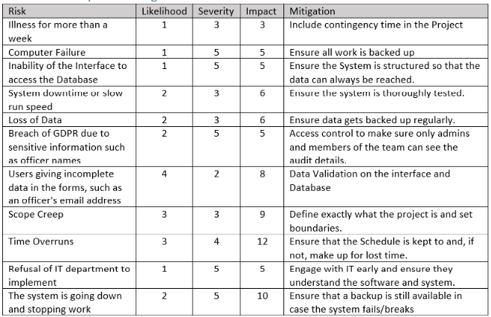
Figure 1: Risk Matrix

Resources required
The resources that my project will need will be
- A force computer to test the system on (already acquired)
- Ability to get into Humberside Police Office ( already have)
- Access to the force hierarchy system for auto-filling sections of the form.
For Access to the force hierarchy system, discussions have taken place with IT, and they have agreed to give me access; however, for the time being, I have been given a sample dataset that can be used to make Mock data to create a system that will work with the data once hooked up, and this is for a nice-to-have feature.

Ethical and legal considerations
This Project needs to consider GDPR as the audits will include officer Names/emails. To mitigate this risk, it must be ensured that only the Crime Data Admin team can access force data. This means the university Submission will use Mock data and putting security measures in place. My project will involve talking to real people and including their feedback in my final report, so it must ensure that any input is gathered in a data-compliant way in accordance with both legal and university rules.

Commercial considerations
Because this is a bespoke product, there are no real competitors that combine all of the comments. There are individual elements like Tableau or Microsoft Forms, but no products combine all of them. Other people who may be interested in the project could be other police forces, as they likely have similar teams in need of similar products. If the project is built with a config file, it could be sold to police forces, allowing them to configure it with their logo and use this.
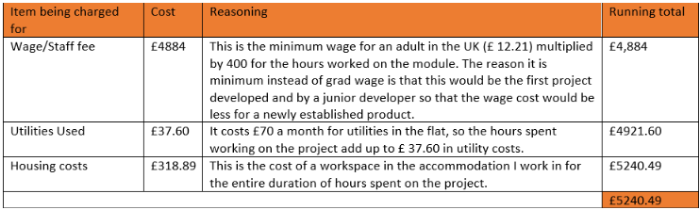
Figure 2: Cost of Product Calculation Grid

Project methodology and outcomes

Initial project plan

Tasks and milestones
This project will be broken down into tasks and sprints in accordance with the Waterfall Methodology. In each step, however, there will be at least one milestone, if not more, through the stages as defined below. At each Milestone, A meeting will take place with the stakeholder to ensure their happiness.
Pre-Design Stage
- Project Definition Document
- Literature Review
- Technology Survey/ Analysis
- Choose the Technology that will be used for development
Milestone 1 – Project Initiation Complete
Design Phase
- Sketching out the user interface design
- Creating wireframes based on the sketches
- Design/Draw the databases required and the table relationships.
- Show stakeholders the Design and ensure they are happy.
- Create personas based on Data Admin Team Experiences.
Milestone 2 – Early Prototyping Complete
- Establish Questions for the Forms
- Design Prototype In a prototyping tool such as Figma
- Sample Data and create Mock data for the application
- Demonstrate the interactive prototypes and ensure that the Data admin team is happy
Milestone 3 – Prototyping/Design Complete

Development Phase
- Build the database/database schema and populate with mock data
- Build the User interface for the Header of the page and the forms section, leaving a placeholder for the dashboard for now
- Fill the Table in the database with form questions
- Hook the Database table up to the forms interface
- Check form displays correctly
- Build Edit form functionality
- Build the Feedback functionality
Milestone 4 – Forms section Complete
- Build the Admin Login System into the Interface
- Lock edit questions functionality to admin
Milestone 5 – Admin Profiles Complete
- Build the dashboards Page
- Build the data charts/Display
- Build a system to highlight recurring issues to the Staff
Milestone 6 – Dashboard complete
- If any leftover time, work on adding Nice to have functionality

Testing
- Manually go through the Project and ensure everything works
- Get members of the data Admin team to conduct UAT
- Collect anonymised user feedback
- Review User Feedback
Milestone 7 – Phase One Testing done
- Act on any user feedback, fixing bugs and issues
- Conduct the second phase of testing.
Milestone 8 – UAT completed
Implementation/Write-up
- Read Me written for the implementation by IT staff
- Final Project Write-up finalised
- Video of completed Project filmed
- Project Submitted

Schedule Gantt chart

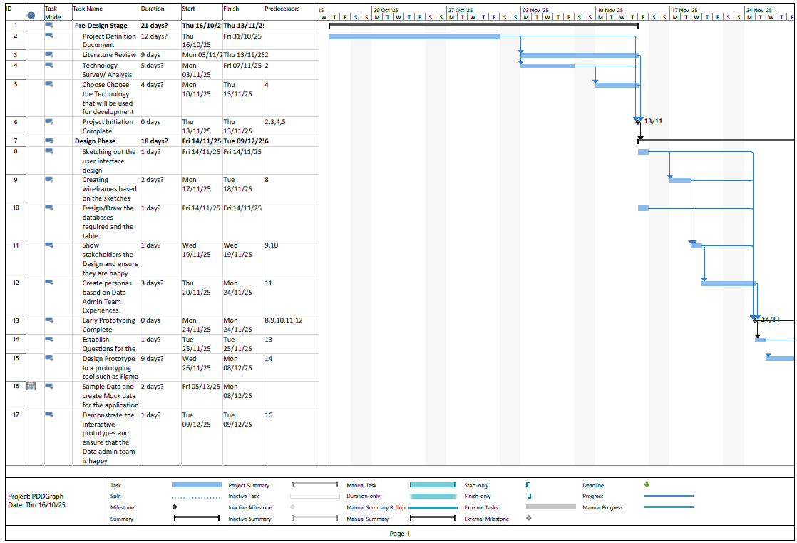
Figure 3: Gantt Chart Top Section
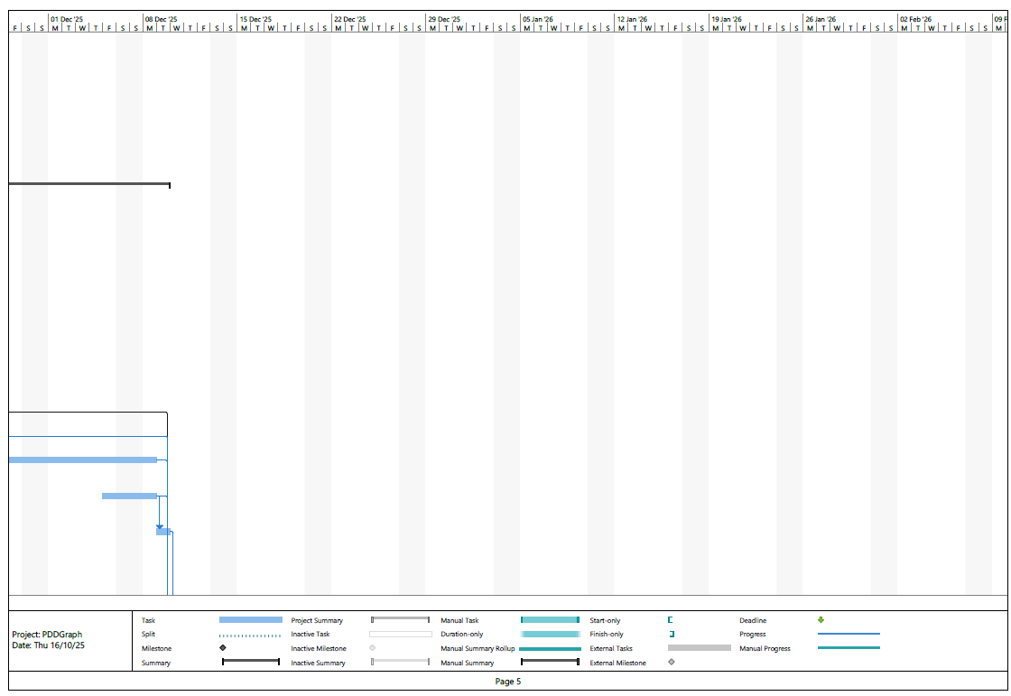
Figure 4 Gantt Chart Top Section Second Part
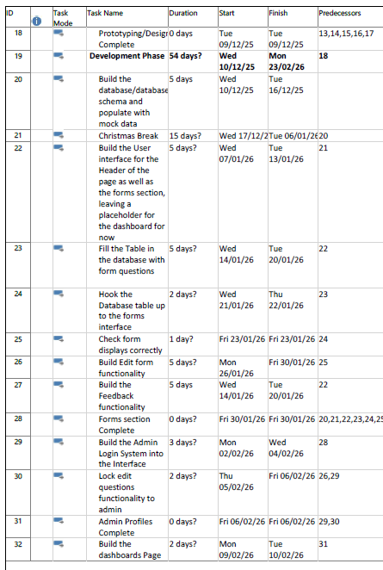
Figure 5 Mid Section Tasks

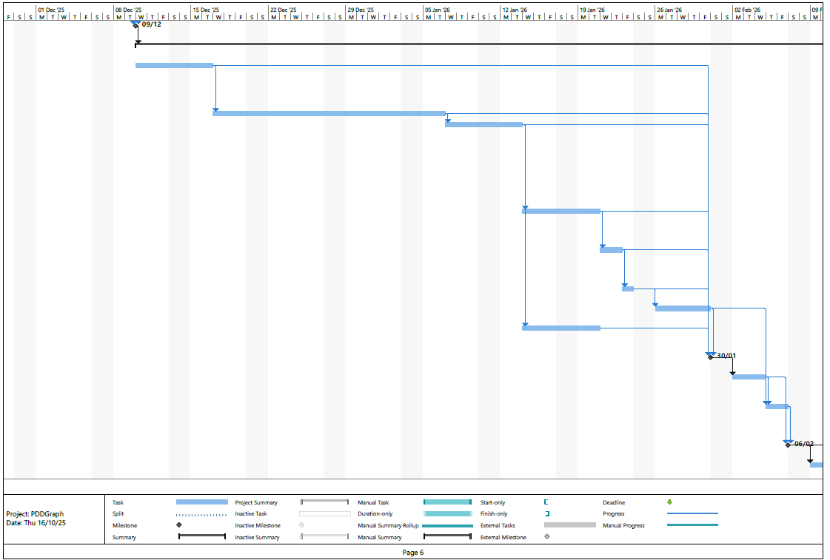
Figure 6: Mid section Gantt Chart
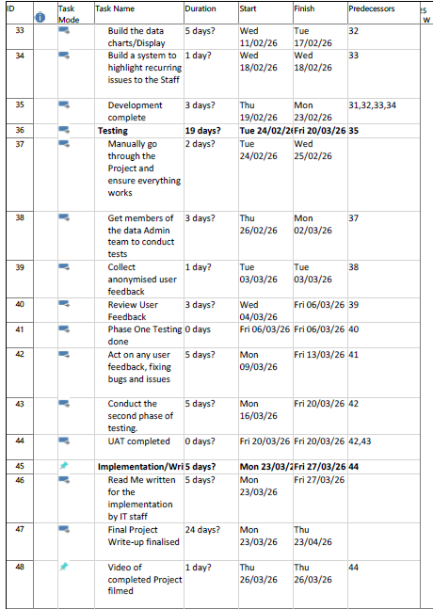
Figure 7: Bottom of Gantt Chart

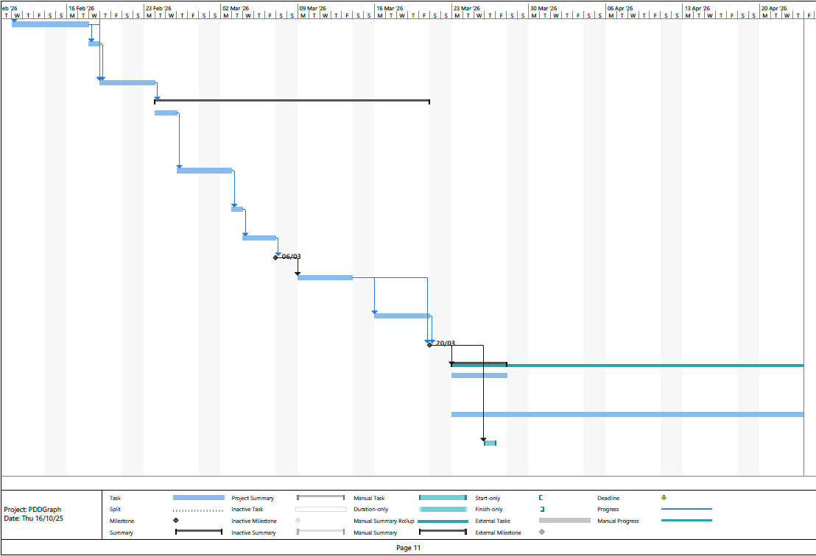
Figure 8 Gantt chart Bottom

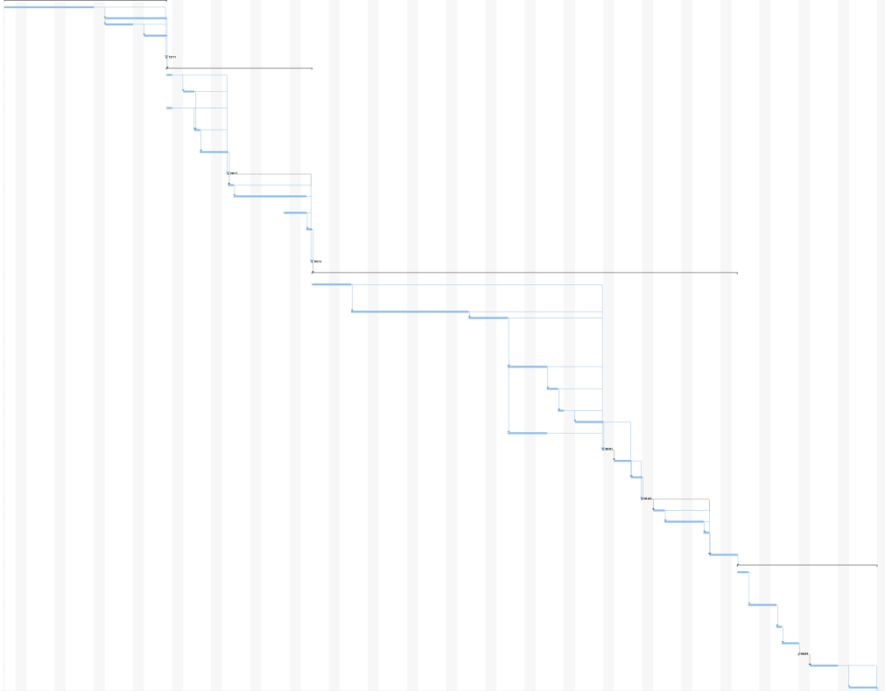
Figure 9: Gantt Chart in full (low visibility)

Project control
Microsoft Planner will be used to monitor progress by creating sections for each task, setting relevant deadlines, and checking them off as the project progresses. This will be assessed against the Gantt chart to ensure that the timeline is met. The intention is to have 8 hours a week set aside for this project.

Project evaluation
The project will be tested on live participants and has been included in the ethics review. Evaluation will be conducted through user feedback gathered via anonymised forms. It will be tested on multiple staff members of different levels, including both staff and management, to ensure everyone is happy with the system. There will be two rounds of testing, with feedback acted on at both occasions. This project will then be evaluated through its ability to meet all objectives and deliver all deliverables.

References
Microsoft. (2025, 10 8). Microsoft Planner. Retrieved from Microsoft: https://www.microsoft.com/en-us/microsoft-365/planner/planner-and-project-support
Niche Technology. (2025, 10 12). nicherms. Retrieved from nicherms: https://nicherms.com/
Salesforce. (2025, 10 15). tableau. Retrieved from tableau: https://www.tableau.com/en-gb

